Scrum Meeting #2

# Nick Kaiser

*Acting scrum master and note taker*

Photo of repository, February 28, 2019.

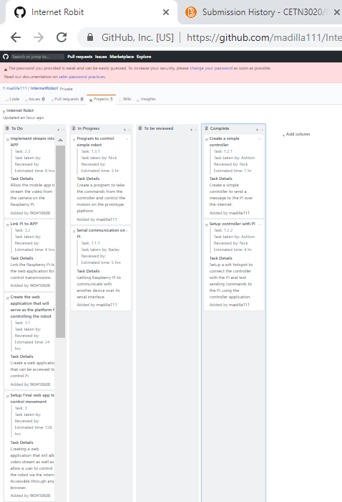

**New tasks:**

Implement stream into APP -

Link Pi to APP -

Create the web application that will serve as the platform for controlling the robot -

Setup Final web app to control movement -

**What was accomplished since last meeting?**

Since the last meeting, A simple mobile controller was created and programmed with 5 buttons. The controller was also configured to send UDP messages to a Raspberry Pi.

**What is in-progress since last meeting?**

Currently, there are two python programs made to sender and receive UDP messages with the Raspberry Pi. Configuring serial communication on the Raspberry Pi is also in progress.

**Impediments & Resolutions**

* Didn’t have the required components for completing the serial communication part
* Python UDP program requires serial to be working in order to define terms in a custom dictionary of commands
* Parts not arriving